


PATUAKHALI SCIENCE

AND TECHNOLOGY

UNIVERSITY

-

CCE 310 :: Software Development Project-I
Sessional Project Proposal

Project Title: PetBondhuBD
Submission Date: Fri 18, July 2025

SUBMITTED BY:  Name: Shaid Ibna Sobhan  ID: 2102057  Reg No: 10184  Patuakhali Science & Technology University | SUBMITTED TO:  1. Prof. Dr. Md Samsuzzaman  Professor,  Department of Computer and Communication Engineering,  Patuakhali Science and Technology University.  2. Arpita Howlader  Associate Professor, Department of Computer and Communication Engineering,  Patuakhali Science and Technology University

Table of Contents
- Abstract ........................................................................................... 3
- Objectives ........................................................................................ 3
- Problem Statement ......................................................................... 3
- Related Work .................................................................................. 3
- Scope ................................................................................................ 4
- Methodology ................................................................................... 4
6.1. Technology Stack .................................................................. 4
6.2. Design Principles .................................................................. 4
- Visual Models ................................................................................. 5
7.1. Flow Chart Diagram ............................................................. 5
7.2. ERD (Entity Relationship Diagram) .................................... 6
7.3. Timeline (Gantt Chart) ......................................................... 6
7.4. UI Mockups .......................................................................... 7
- Limitations ..................................................................................... 9
- Result .............................................................................................. *

PetBondhuBD

1. Abstract
PetBondhuBD is a cross-platform Flutter app addressing the fragmented pet care ecosystem in Bangladesh. It integrates health tracking, AI-powered lost pet recovery, and an essentials marketplace into one intuitive platform. Targeting 5M+ pet owners, the app leverages Firebase and Google Vision AI to deliver localized solutions for vaccination reminders, emergency alerts, and doorstep delivery of pet supplies.

2. Objectives
Primary: Develop a unified pet care app for Android/iOS with:
- ✔️ Multi-pet profiles (breed, age, medical history)
- ✔️ AI lost pet finder (photo matching + geo-alerts)
- ✔️ E-commerce integration (food, meds, accessories)
Key Metrics:
- Reduce vaccine missed doses by 70%
- Achieve 80% lost pet recovery rate via AI
- Onboard 100+ Dhaka-based pet stores in Phase 1

3. Problem Statement
Bangladeshi pet owners face:
- 📉 No centralized platform: 3+ apps needed for basic care.
- 🚨 Inefficient lost pet recovery: Reliance on social media.
- 💊 Supply gaps: 60% struggle to find specialized pet products locally (Source: Dhaka Pet Owners Survey 2023).

4. Related Work
App | Focus | Limitations
PetDesk | Health tracking | US-centric, no marketplace
Pawscout | Lost pets | No AI/BD localization
PetBondhuBD | All-in-one | Tailored for Bangladesh

5. Scope
In-Scope:
- Flutter-based mobile app (Android/iOS)
- Firebase backend (Auth, Firestore)
- Google Vision AI integration
- Dhaka-focused pilot
Out-of-Scope:
- IoT wearables (Phase 2)
- Non-Bengali language support

6. Methodology
6.1 Technology Stack
Layer | Tools
Frontend | Flutter 3.13, Dart
Backend | Firebase Auth, Firestore, Cloud Functions
AI | Google Vision API
DevOps | GitHub Actions, Play Store/App Store
6.2 Design Principles
- Offline-first: Low-bandwidth functionality
- MUIS: Minimalist UI with Bengali typography
- GDPR Compliance: Encrypted pet health data

7. Visual Models
7.1 Flow Chart Diagram
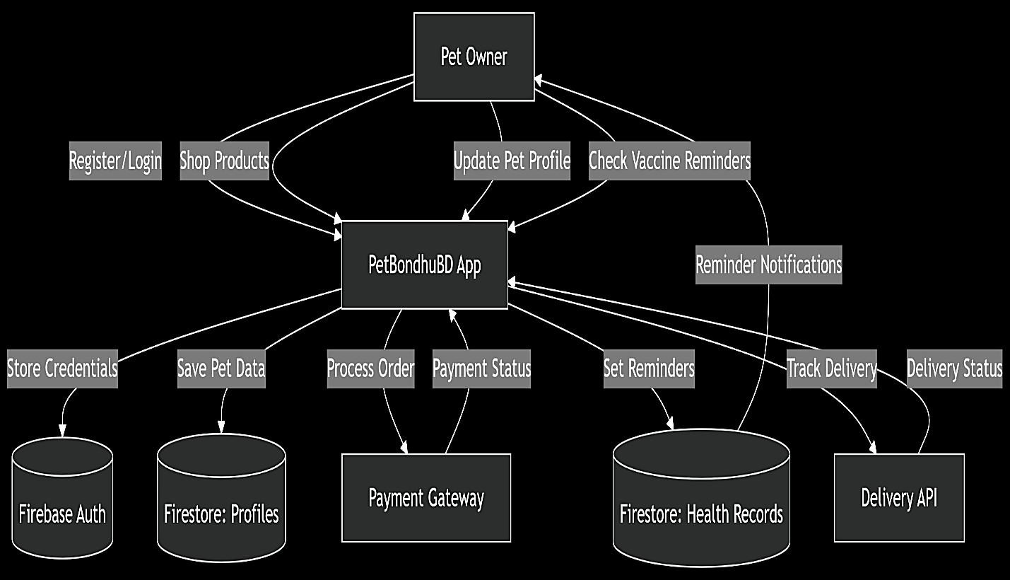

7.2 ER Diagram
- Entities: User, Pet, Order, VaccineRecord
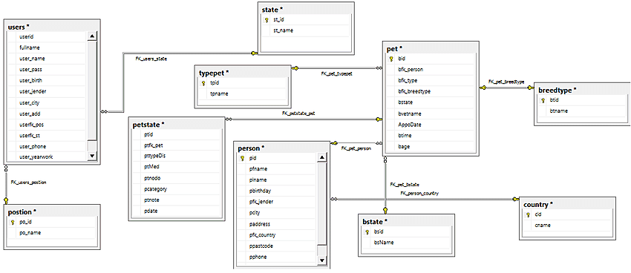

7.3 Gantt Chart
Task | Start Day | End Day | Duration | Timeline (Gantt View)
Requirements Gathering | Day 1 | Day 14 | 2 weeks | ██████████████
UI Mockups | Day 15 | Day 28 | 2 weeks | ██████████████
Firebase Auth | Day 15 | Day 21 | 1 week | ███████
Pet Profiles | Day 22 | Day 28 | 1 week | ███████
Vaccine Reminders | Day 29 | Day 35 | 1 week | ███████
AI Lost Pet Finder | Day 36 | Day 49 | 2 weeks | ██████████████
E-Commerce Module | Day 50 | Day 63 | 2 weeks | ██████████████
Delivery Tracking | Day 64 | Day 70 | 1 week | ███████

7.4 UI Mockups
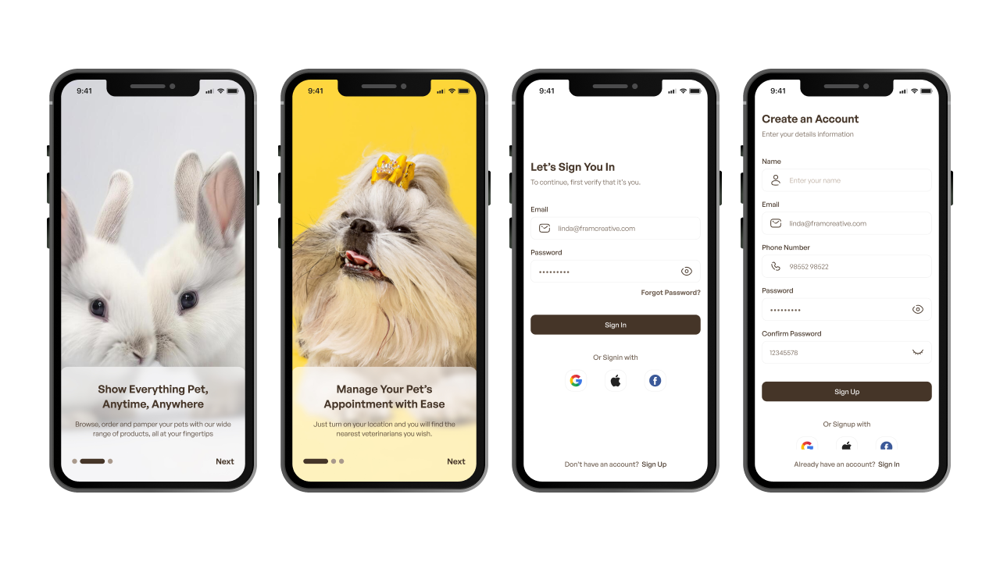

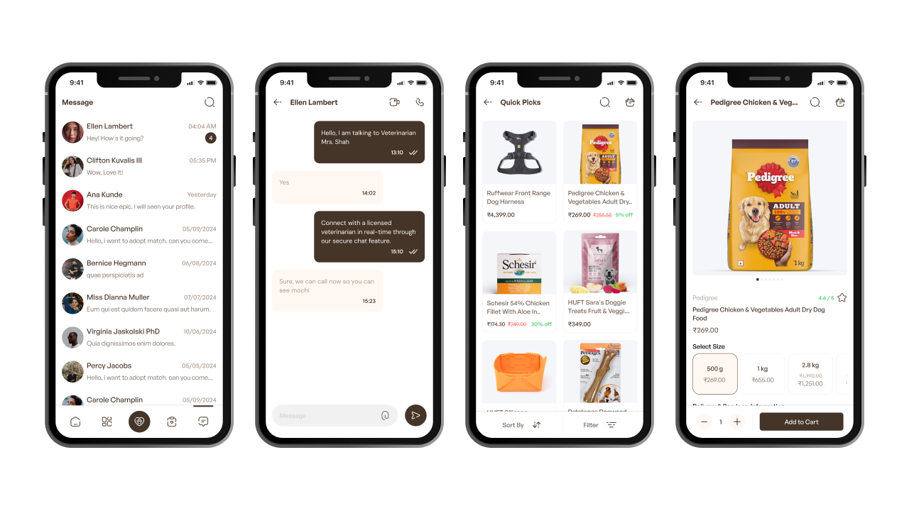

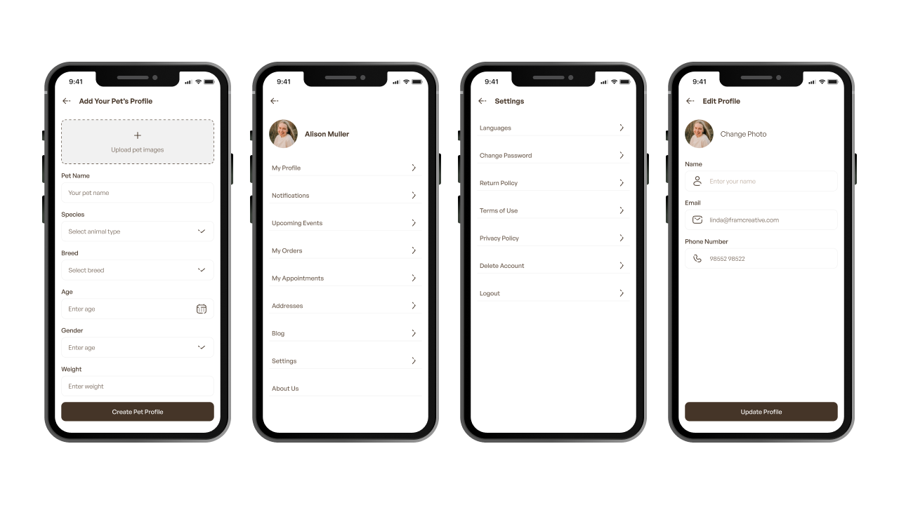

8. Limitations
- 🐕 Mixed-breed accuracy: AI works best with purebred pets.
- 📶 Rural connectivity: Offline mode required.

9. Expected Results
- 10K+ downloads in 6 months
- 40% fewer lost pets (AI matching)
- 70% more vaccines (auto-reminders)
- Impact: Saves time, builds pet community.

